

An International Technical Symposium

In association with SENSE-VIT

20th January 2017 – 22nd January 2017

(For external participants only)

Applicant Information:

First Name: __________________________________________________________________________________

Last Name: __________________________________________________________________________________

College/School: _____________________________________________________________________________

College/School ID No.:______________________________________________________________________

Address: _____________________________________________________________________________________

City: ________________________________State: ___________________________________________________

Mobile No. :________________________ Email ID: ______________________________________________

Event (please put a tick mark):
- Machine Learning Workshop [Rs.900/participant(Non IETE)]

- Machine Learning Workshop [Rs.700/Participant(IETE Member)]
 | VLSI Design Workshop | [Rs.1000/participant(Non IETE)]
 | VLSI Design Workshop | [Rs.800/Participant(IETE Member)]
 | Paper Presentation | [Rs.500/participant][Max team of 3]
 | Code-Olympia | [Rs.300/participant][Max team of 2]
 | Project Presentation | [Rs.200/participant][Max team of 2]
 | Cultural Night | [Rs.350/participant]
 | Combo1 | [Rs.1100/participant]
 | Combo2 | [Rs.1400/participant]
 | Combo3 | [Rs.1300/participant]
 | Combo4 | [Rs.900/participant]

Demand Draft Details:

Amount: _____________________________ DD No.:_______________________________________________

Bank & Branch: _____________________________________________________________________________

Dated: _______________________________ Signature: ___________________________________________

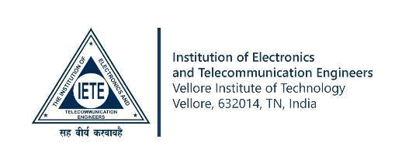
Payment Option:

Completed Application Form should be accompanied with Demand Draft drawn in favour of “IETE - VIT University” payable at “VELLORE”.

Send To:

Professor Kishore V Krishnan,

Assistant Professor (Senior) & Faculty Coordinator- IETE,

School of Electronics Engineering,

VIT University, Vellore, 632014

Accommodation: Available at VIT Hostel Dorm on request.

For further information:

Website: synergy.ietevit.in

Contact: Shubham-9566698400

Manvith-7639799093

Email: ietevit@vit.ac.in

Facebook: /ieteisf

